# **Name: Abdurrahman Qureshi**

# **Roll No: 242466**

Practical No: 2

Date Of Performance: 15/01/2024

Aim: To Learn various network commands

Lab Objectives:

To learn and practice various network commands such as ping, tracert/traceroute, arp, netstat, ipconfig, nbstat, systeminfo, pathping, getmac, hostname, nslookup

Lab Outcomes:

Understand the usage and functionality of key network commands for troubleshooting and monitoring.

1) ping

* Checks if a device is reachable on the network by sending test messages and measuring the response time.
* Helps verify connectivity and speed.

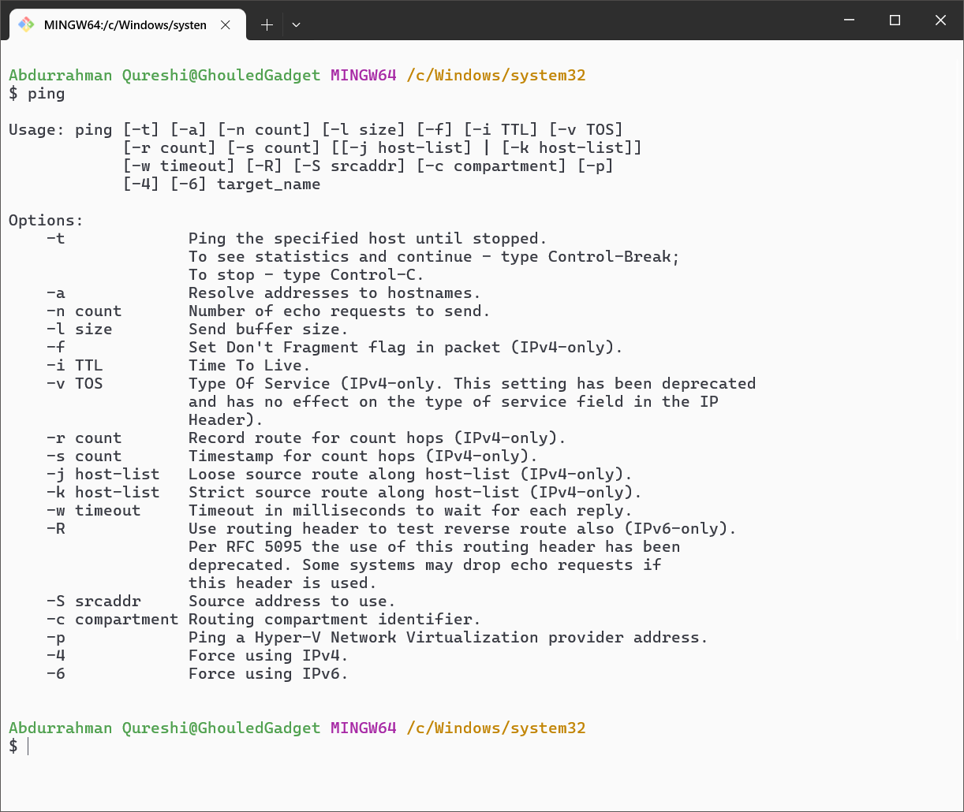

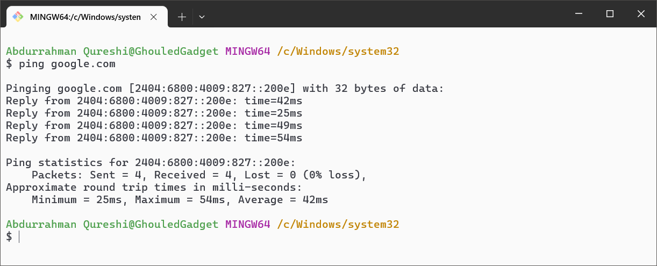

2) tracert/tracerouten

* Shows the path data takes to reach a destination, listing all devices (hops) it passes through.
* Useful for finding delays or connection issues.

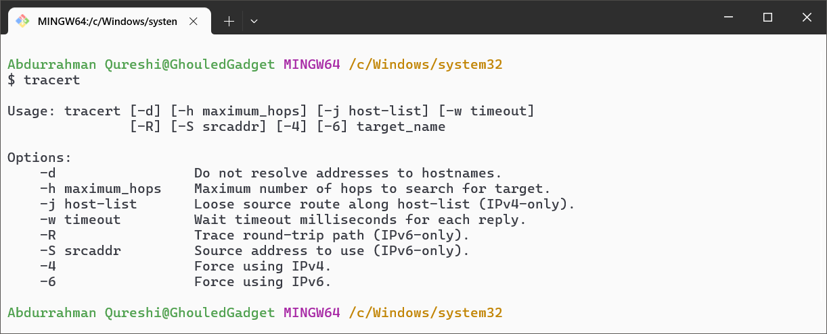

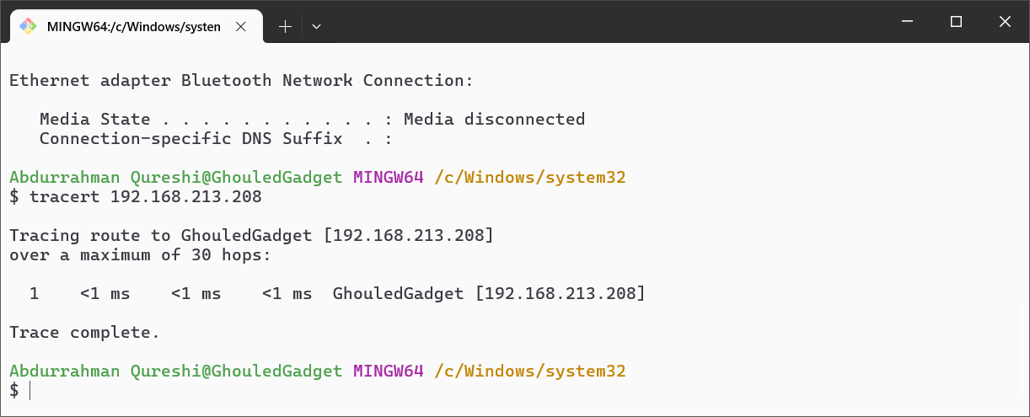

3) ipconfig

* Shows your computer’s network settings, like IP address and gateway.
* Useful for troubleshooting or setting up connections.

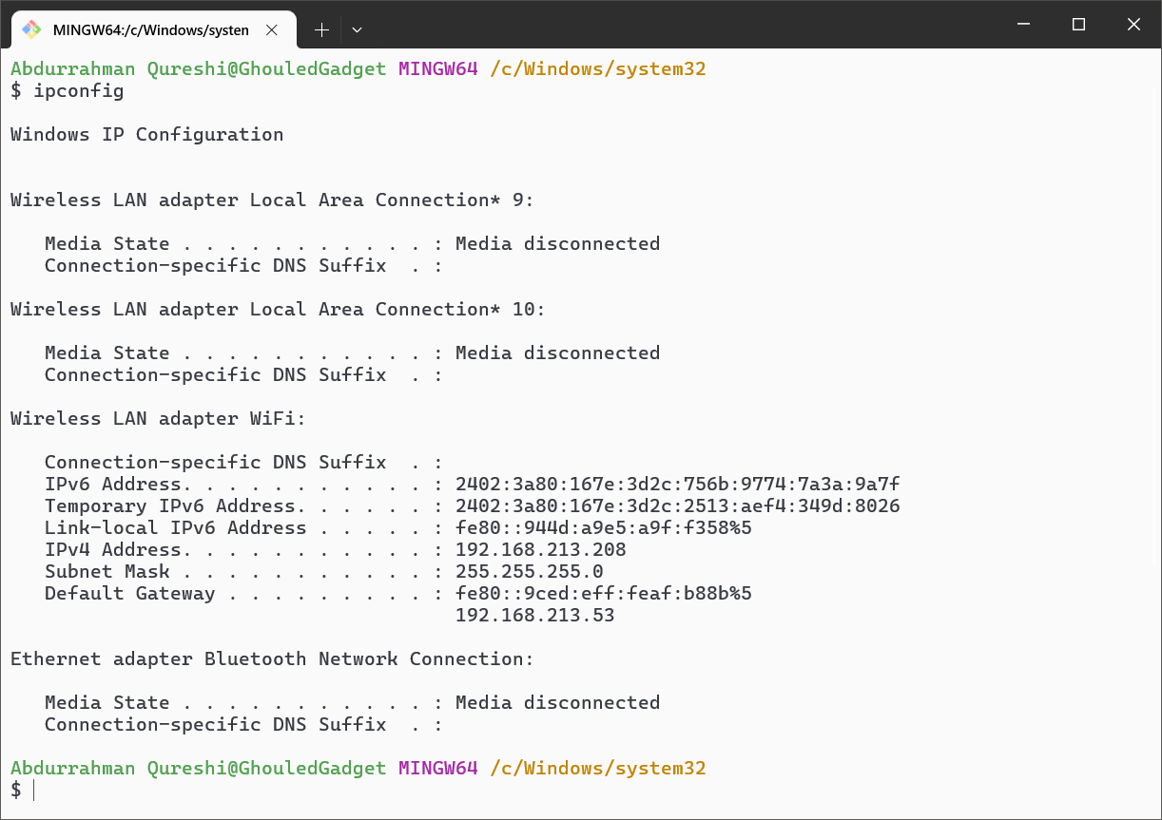

4) ****netstat****

* Lists all active network connections and ports.
* Helps check what apps are using the network and spot unusual activity.

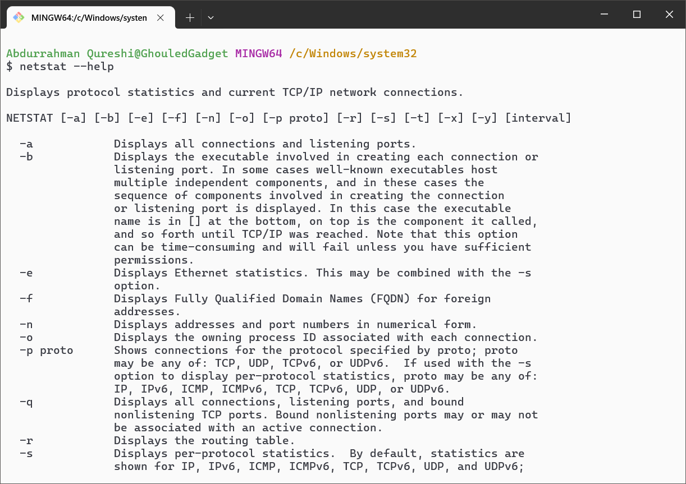

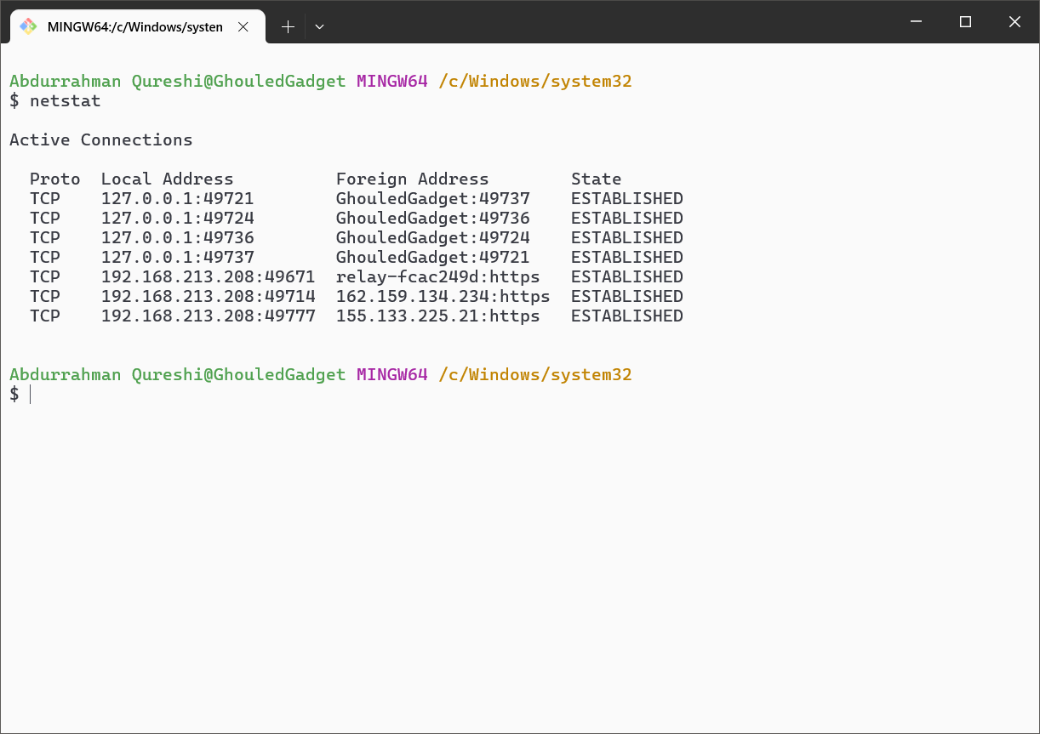

5) ****nbstat****

* Gives information about devices on your network using Windows file-sharing names.
* Helps troubleshoot name conflicts and connectivity.

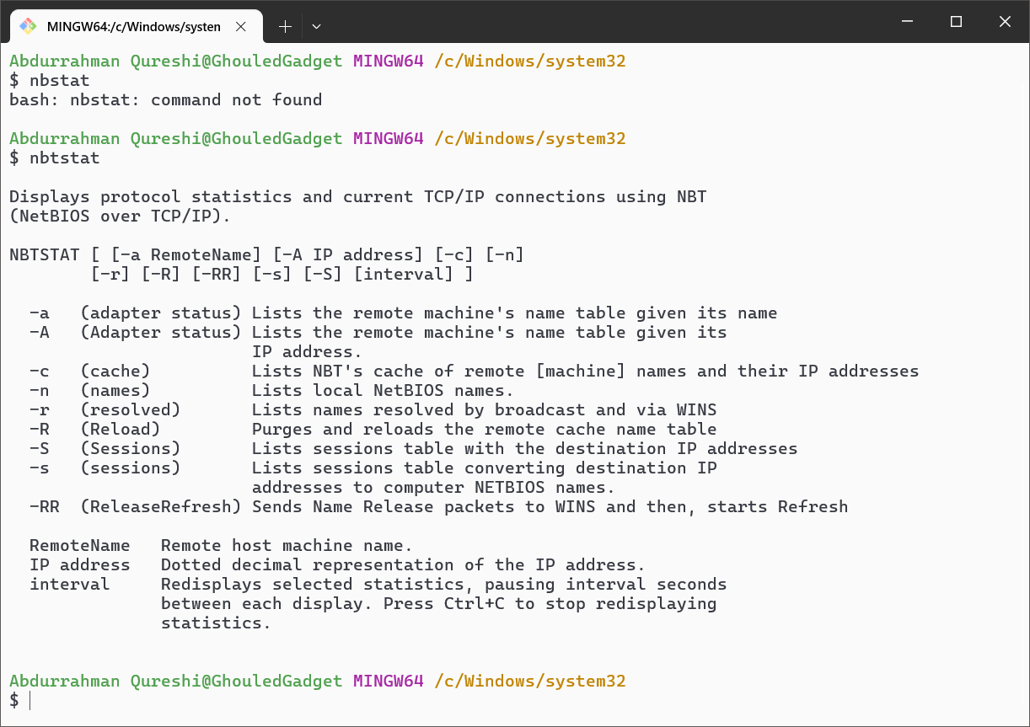

6) ****Systeminfo****

* Displays detailed system information like the operating system, network adapters, and hardware.
* Useful for checking system capabilities or diagnosing problems.

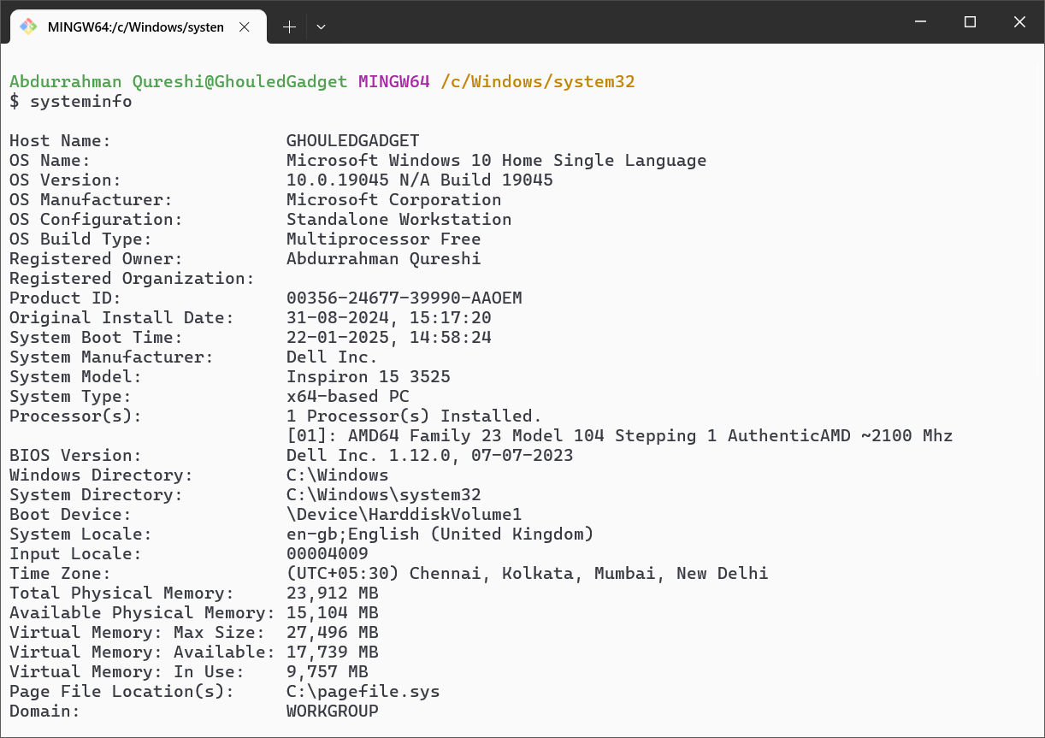

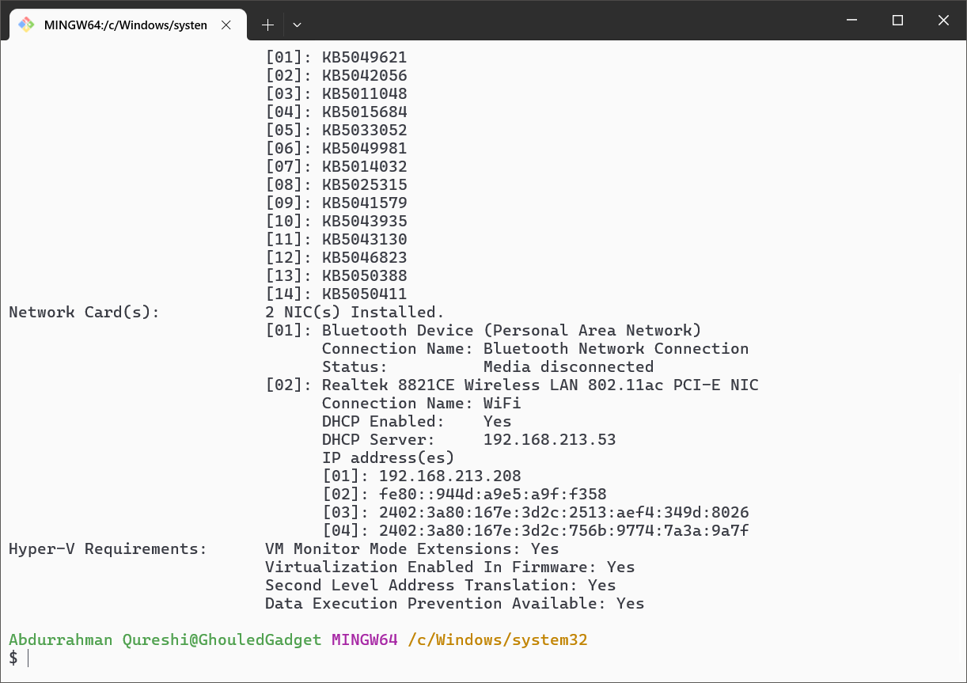

7) ****Pathping****

* Combines ping and tracert to show network path details and packet loss.
* Helps identify where network issues are occurring.

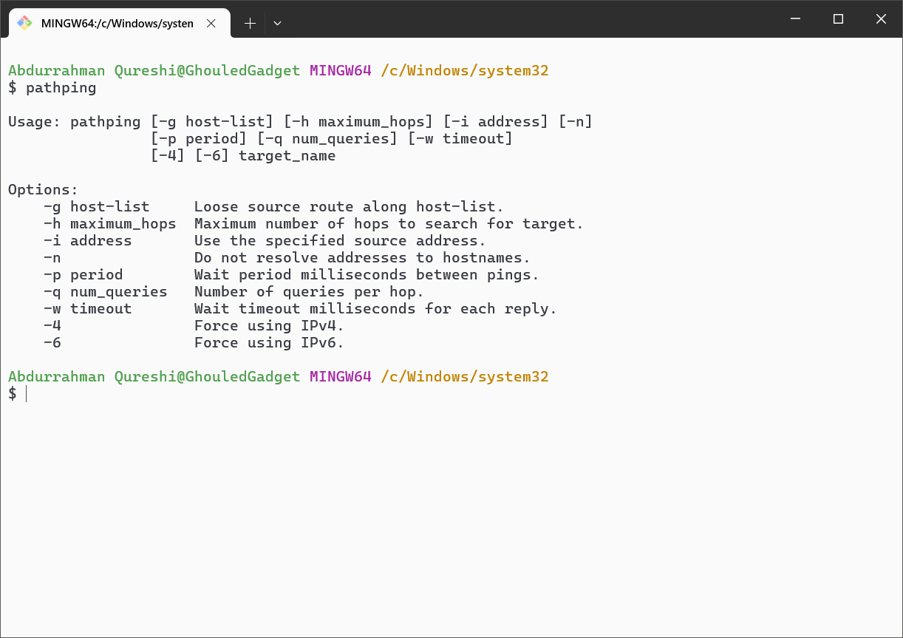

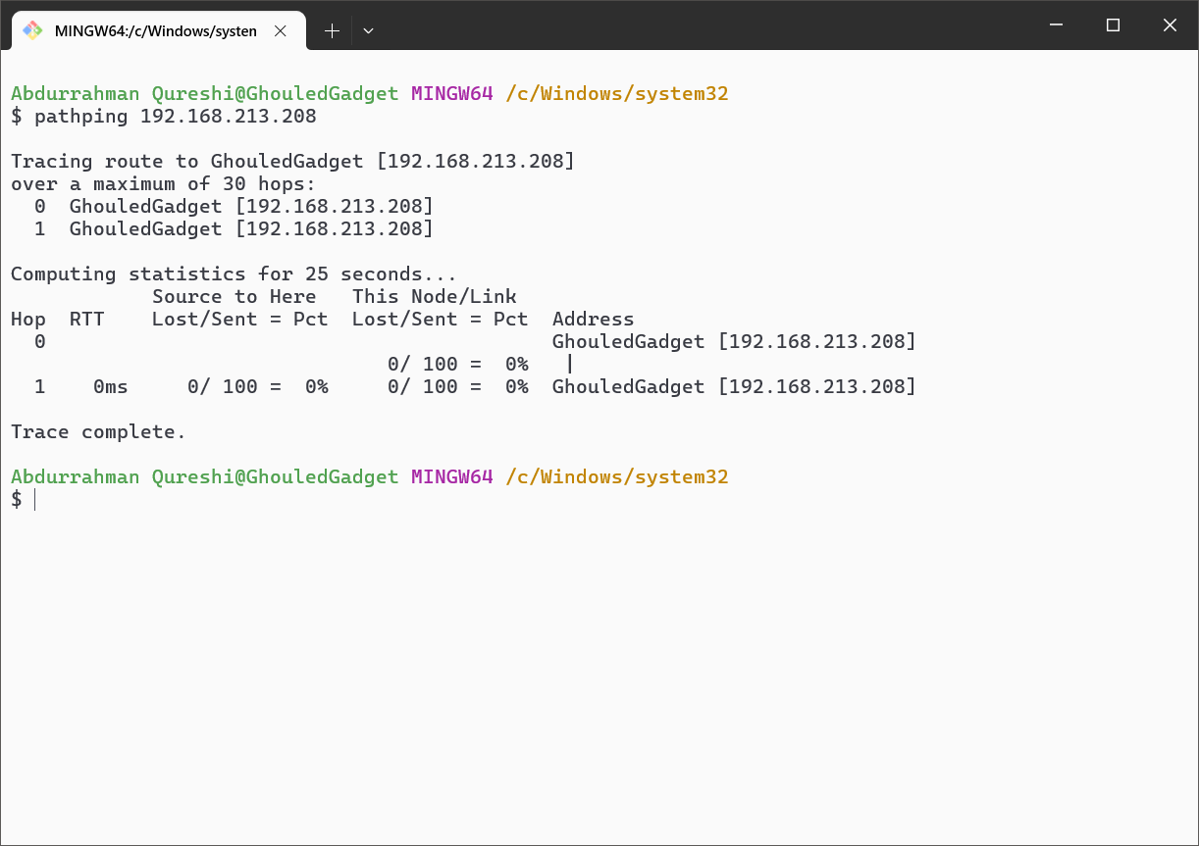

8) ****Getmac****

* Shows the unique MAC address for your computer’s network adapters.
* Useful for network identification or troubleshooting.

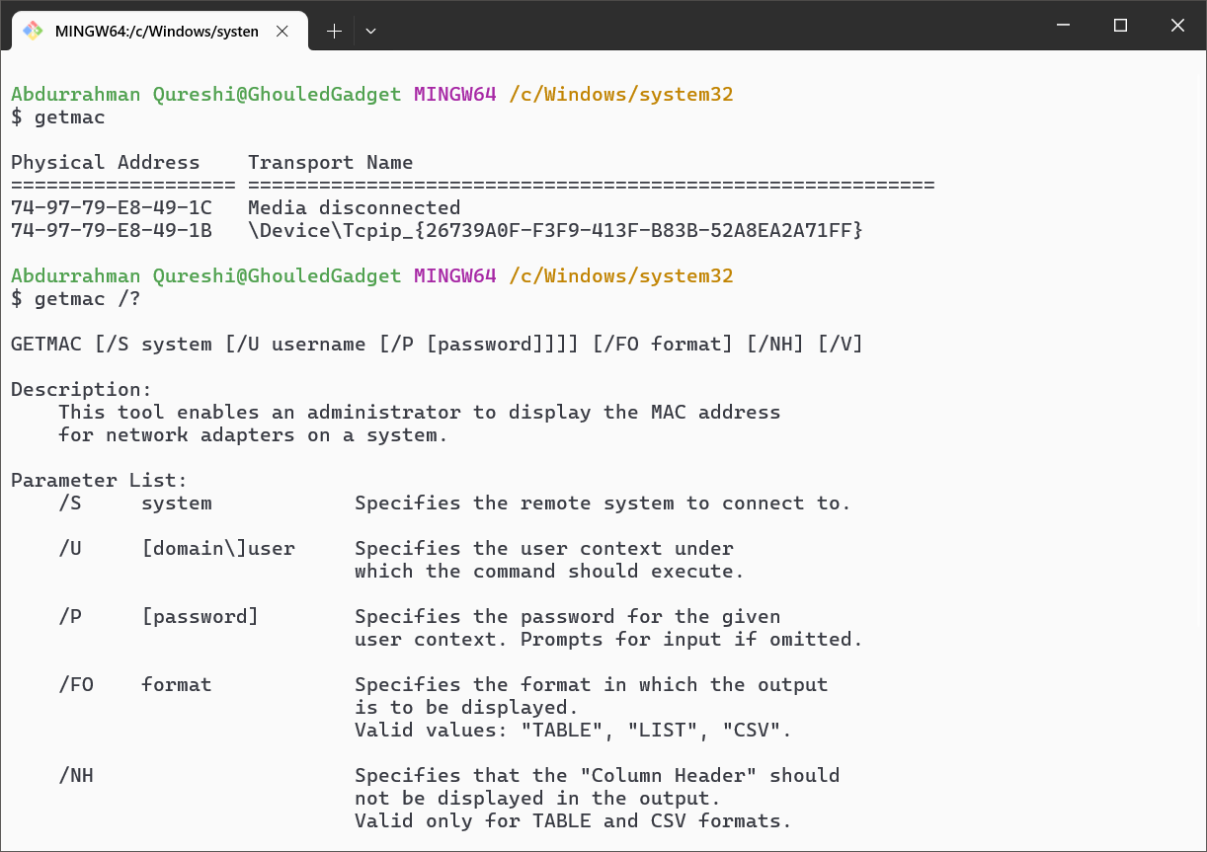

9) ****Hostname****

* Shows your computer’s name on the network. Useful for identifying devices or fixing naming conflicts.

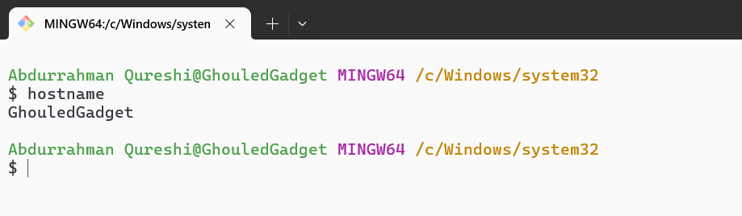

10) ****nslookup****

* Checks how domain names are translated into IP addresses.
* Helps troubleshoot website or DNS issues.

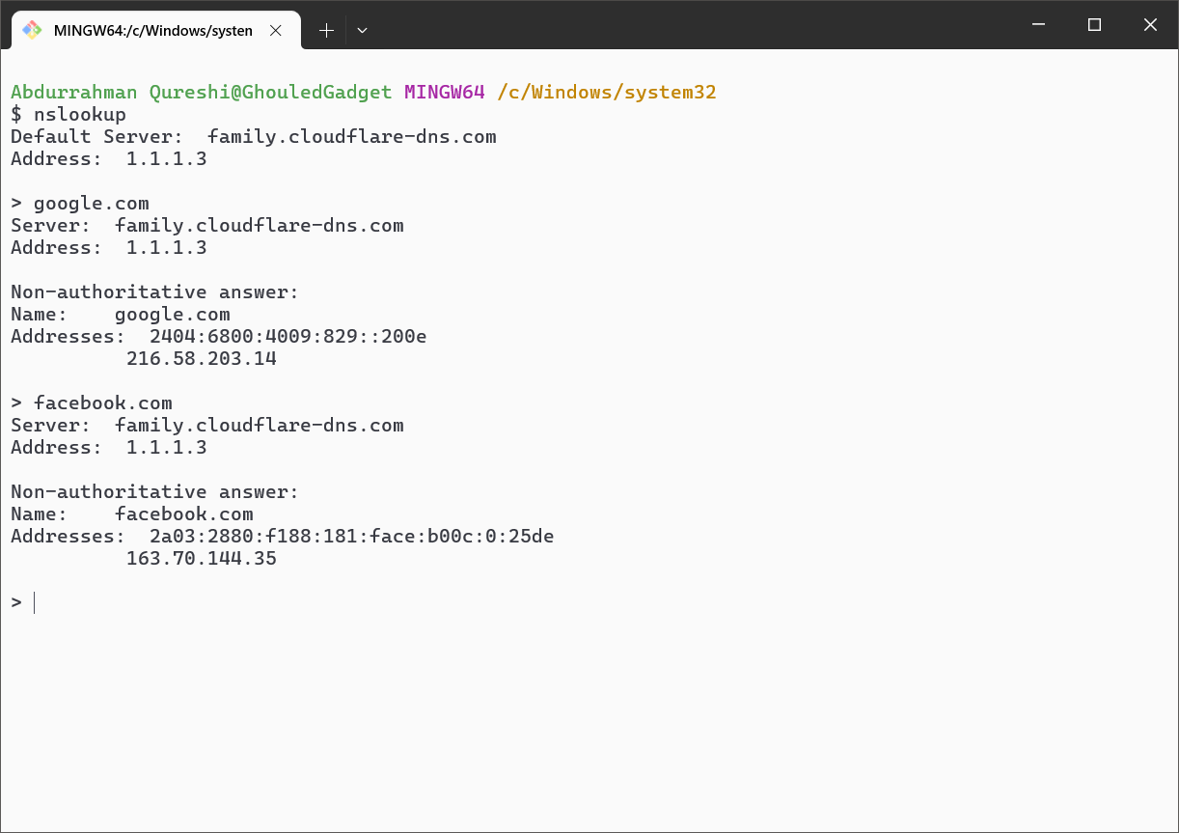

11) ****arp****

* Shows or updates the list of IP addresses and their corresponding MAC addresses on your network.
* Useful for fixing local network problems.

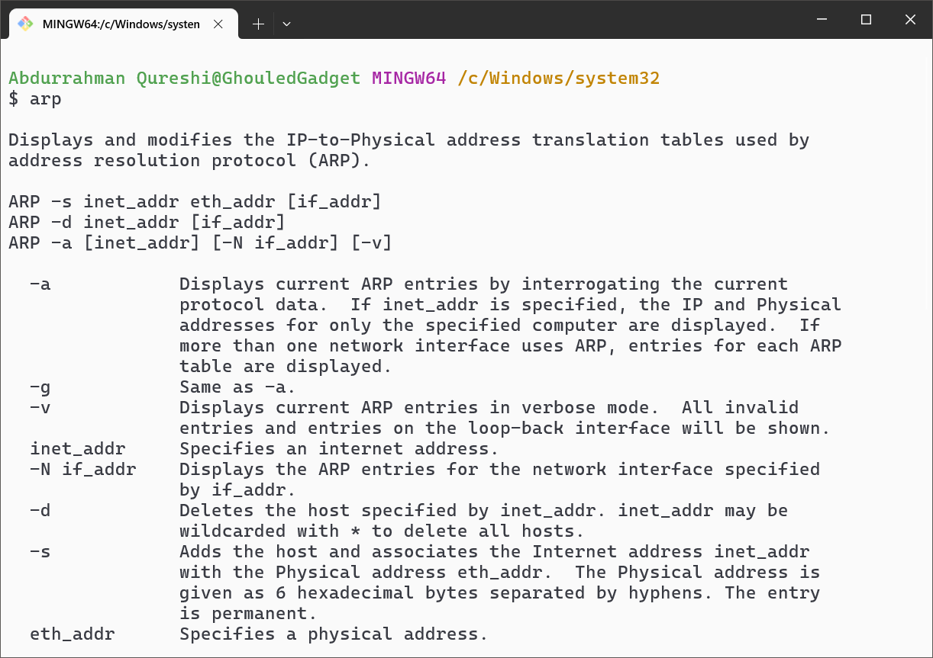

Conclusion:

In conclusion, network commands like and others are vital tools for diagnosing and managing networks. Understanding their functionality enables effective troubleshooting, monitoring, and ensuring reliable connectivity in various network environments.

|  |  |  |  |  |  |
| --- | --- | --- | --- | --- | --- |
| Performance  (7M) | Journal  (3M) | Lab Ethics  (2M) | Attendance  (3M) | Total  (15M) | Faculty Signature |
|  |  |  |  |  |  |